ARTIFICIAL INTELLIGENCE AND MACHINE LEARNING

AI LAB EXPERIMENTS

Name : Yadlapalli Chaithanya
Reg.No : 1925260210
Subject Code : CSA1720
Slot : A
Submitted To : Dr. Arul U (Sir)

1. 8-PUZZLE PROBLEM
AIM
To write a Python program to solve the 8-Puzzle problem using the A* search algorithm with Manhattan-distance heuristic.

ALGORITHM
1. Represent the 8-puzzle as a 3×3 tuple, where 0 denotes the blank tile.
2. Store the initial state in a priority queue.
3. Calculate f(n) = g(n) + h(n), where g(n) is the path cost and h(n) is the Manhattan distance.
4. Remove the state having the smallest f(n).
5. Generate all valid states by moving the blank tile up, down, left, or right.
6. Ignore states that have already been visited with a lower cost.
7. Continue until the goal state is reached.
8. Print the sequence of states from the initial state to the goal state.

PROGRAM
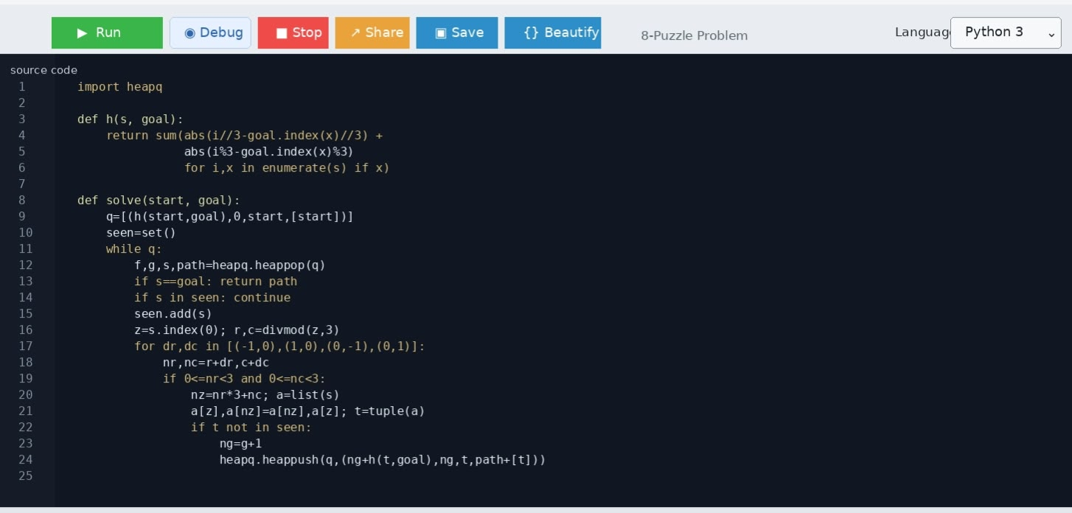

OUTPUT:
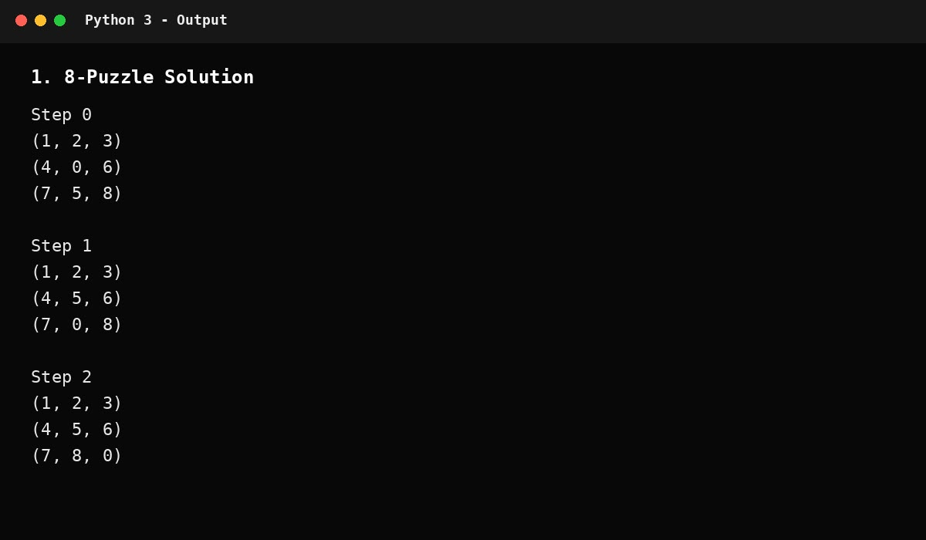

RESULT
Thus, the Python program successfully solved the 8-Puzzle problem using A* search and reached the goal state.

2. 8-QUEEN PROBLEM
AIM
To write a Python program to solve the 8-Queen problem using backtracking.

ALGORITHM
1. Place one queen in each row of the chessboard.
2. Start from the first row and try every column.
3. Check whether the selected position is safe from previously placed queens.
4. A position is unsafe if another queen is in the same column or diagonal.
5. If the position is safe, place the queen and move to the next row.
6. If no column is possible, backtrack to the previous row and change its position.
7. Continue until all 8 queens are placed.
8. Display the valid board configuration.

PROGRAM
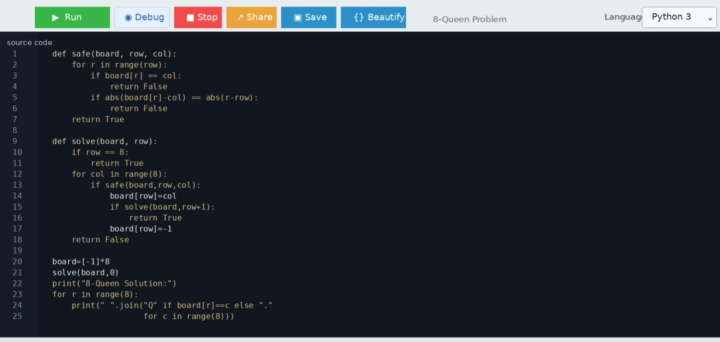

OUTPUT:
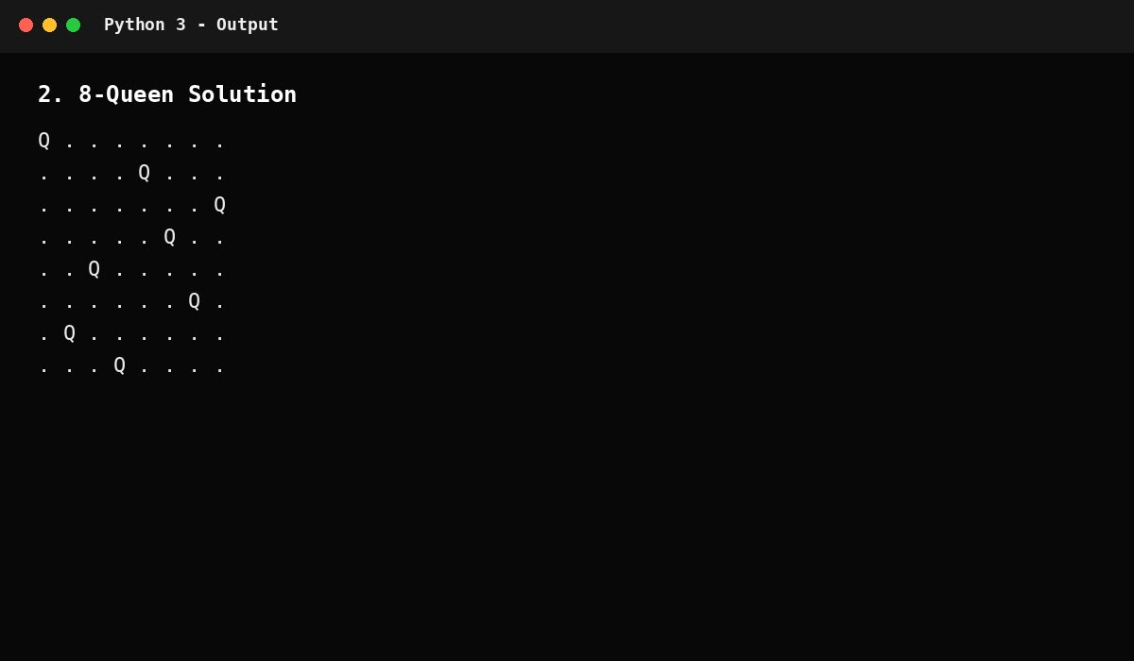

RESULT
Thus, the Python program successfully solved the 8-Queen problem using the backtracking technique.

3. WATER JUG PROBLEM
AIM
To write a Python program to solve the Water Jug problem using state-space search.
PROBLEM / ASSUMPTION
Problem Assumption
Two jugs of capacities 4 litres and 3 litres are available. Initially both are empty. The objective is to obtain exactly 2 litres in the 4-litre jug.

ALGORITHM
1. Represent a state as (x, y), where x and y are the amounts in the 4 L and 3 L jugs.
2. Start from (0, 0).
3. Generate valid operations: fill either jug, empty either jug, pour 4 L into 3 L, and pour 3 L into 4 L.
4. Use BFS so that repeated states are not processed.
5. Store the parent of every new state to reconstruct the solution.
6. Stop when the 4-litre jug contains 2 litres.
7. Print all states in the solution path.

PROGRAM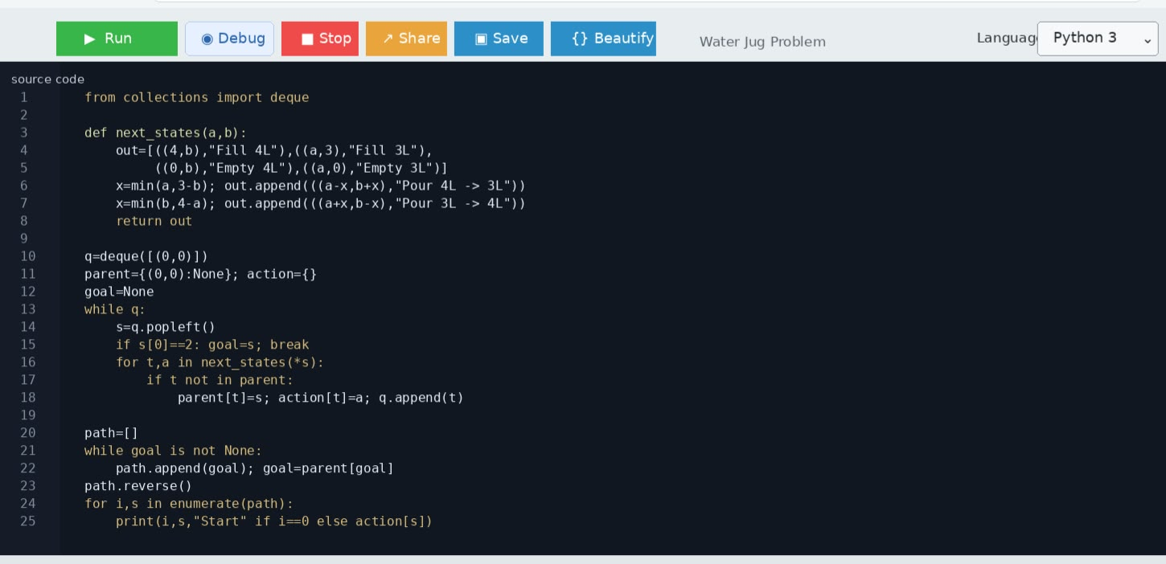

OUTPUT:
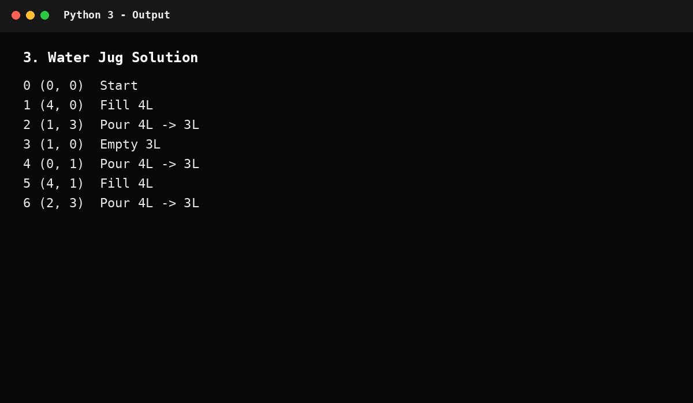

RESULT
Thus, the Python program successfully obtained exactly 2 litres in the 4-litre jug.

4. CRYPT-ARITHMETIC PROBLEM
AIM
To write a Python program to solve a Crypt-Arithmetic problem by assigning unique digits to letters.
PROBLEM / ASSUMPTION
Problem
SEND + MORE = MONEY

ALGORITHM
1. Identify all distinct letters in the equation.
2. Assign a different digit from 0 to 9 to each letter.
3. Do not assign zero to a leading letter.
4. Generate possible digit permutations.
5. Substitute the digits into SEND, MORE and MONEY.
6. Check whether SEND + MORE equals MONEY.
7. Stop at the first valid assignment and display the mapping and equation.

PROGRAM
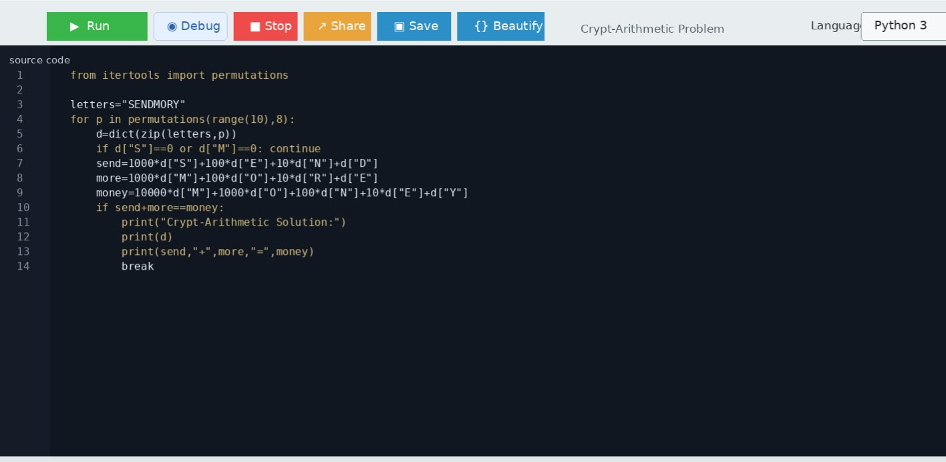

OUTPUT
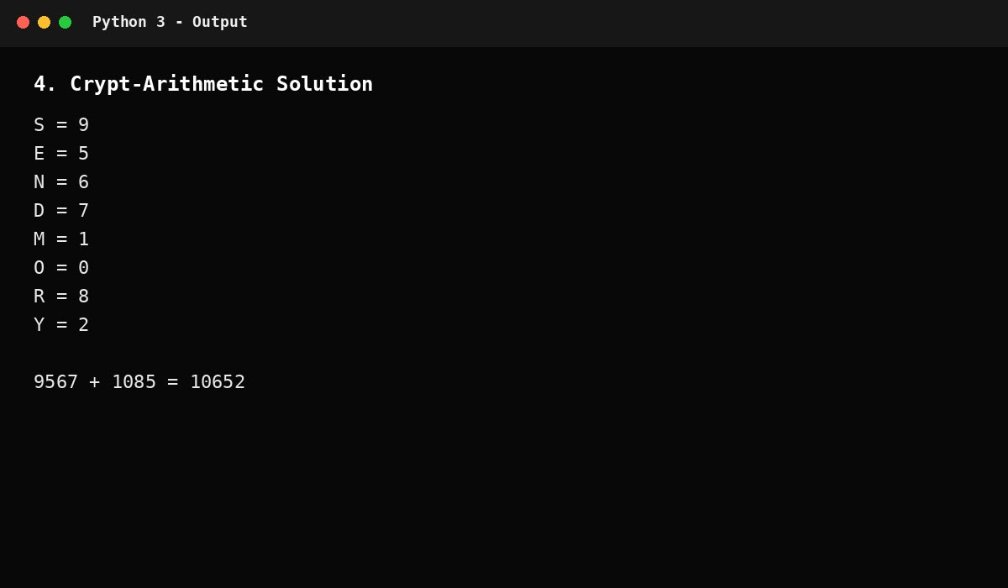

RESULT
Thus, the Python program successfully solved the Crypt-Arithmetic problem and found a valid digit assignment for all letters.

5. MISSIONARIES AND CANNIBALS PROBLEM
AIM
To write a Python program to solve the Missionaries and Cannibals problem using BFS.
PROBLEM / ASSUMPTION
Problem Assumption
There are 3 missionaries and 3 cannibals on the left bank of a river. A boat can carry at most two people. The goal is to move everyone to the right bank without ever allowing cannibals to outnumber missionaries on a bank where missionaries are present.

ALGORITHM
1. Represent a state as (M_left, C_left, boat_side).
2. Start with (3, 3, 0), where 0 means the boat is on the left.
3. Generate possible boat loads: one missionary, one cannibal, two missionaries, two cannibals, or one of each.
4. Move the selected people according to the boat side.
5. Check that the resulting state is safe on both banks.
6. Use BFS and mark visited states to avoid loops.
7. Stop when the state (0, 0, 1) is reached.
8. Reconstruct and print the sequence of crossings.

PROGRAM
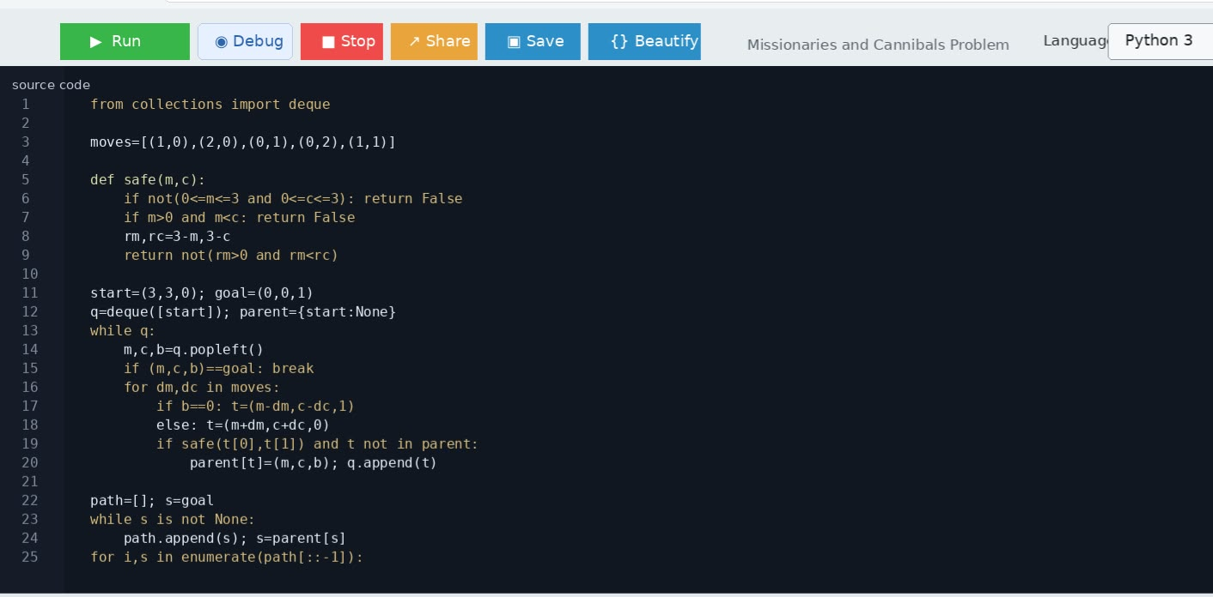

OUTPUT
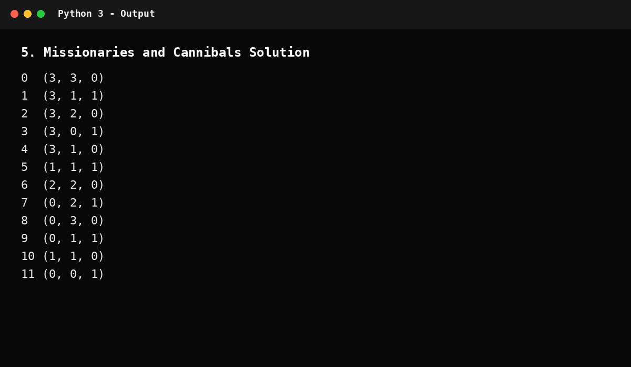

RESULT
Thus, the Python program successfully solved the Missionaries and Cannibals problem using BFS while maintaining the safety constraints.

